Name and DOB Database
AIM:
To write a Prolog program to create a database containing names and dates of birth and retrieve the stored information.
ALGORITHMS:
- Start.
- Define facts containing names and dates of birth.
- Create a rule to retrieve the date of birth for a given name.
- Query the database with a person's name.
- Display the corresponding date of birth.
- Stop.
CODE:
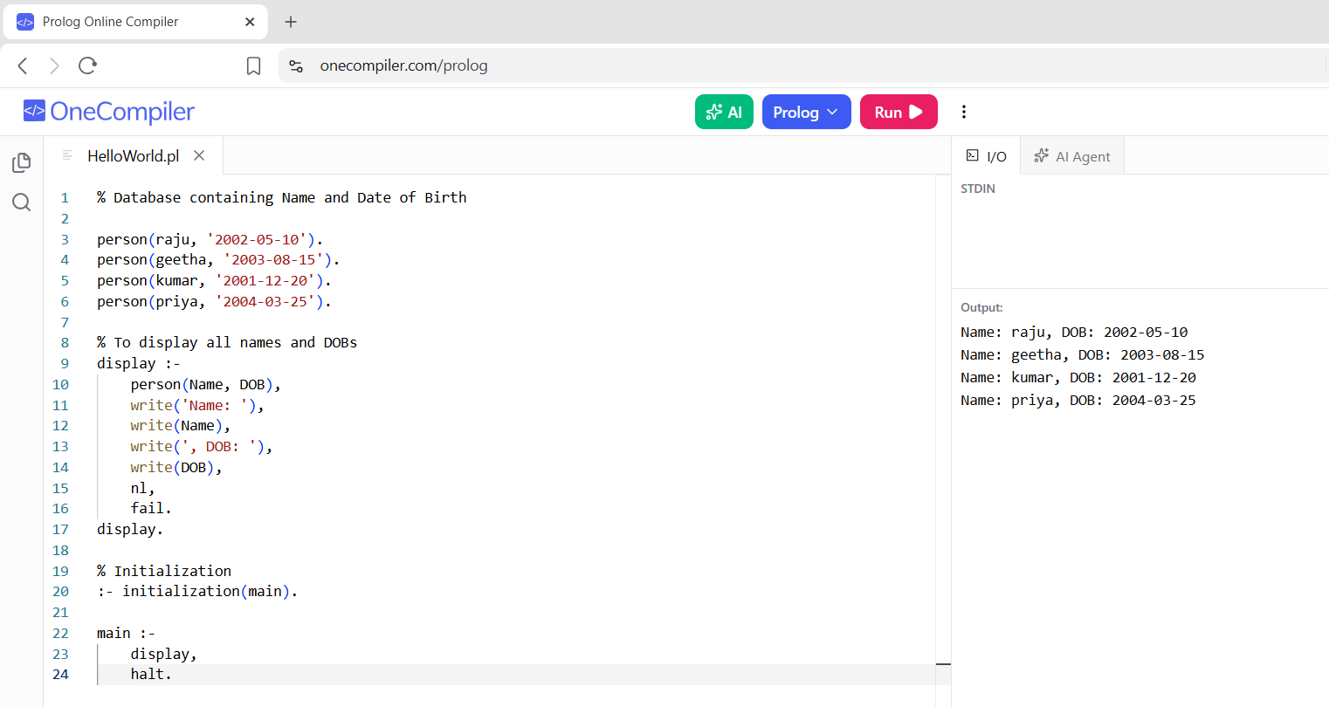

RESULTS:
The name and corresponding date of birth are retrieved and displayed from the database.

